6D5N HANOI – SAPA – HALONG

DAY 1: HANOI ARRIVAL – CITY TOUR ( D )
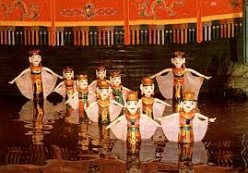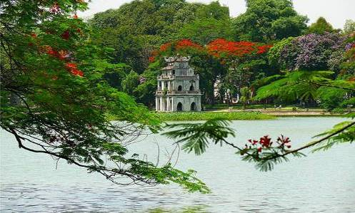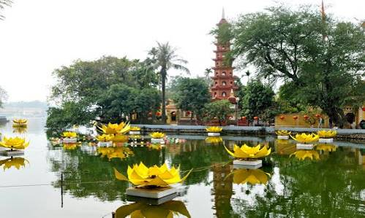
Water Puppet Show Hoan Kiem Lake Tran Quoc Temple
Upon arrival at Noi Bai International airport transfer to downtown visit West Lake, Tran Quoc Pagoda, Hoan Kiem Lake (Restored Sword Lake), Shopping at 36 Hanoi Old Quarters, visit French Opera, enjoy Vietnam Famous Water Puppet Show. Dinner and overnight in Hanoi.

Meals: 1 Dinner
Accommodation: Overnight in Hanoi.
The distance: Noi Bai Airport – Hanoi Capital: 35km – 45 minutes for transfer
DAY 2: HANOI CITY – HALONG (B/L/D)
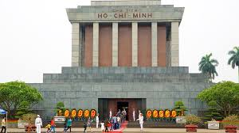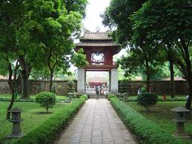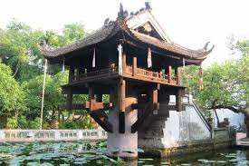
Ho Chi Minh Mausoleum Temple Of Literature One Pillar Pagoda
Breakfast at hotel, Starting city tours with Ba Dinh Square, Ho Chi Minh Mausoleum, His Former Residence, One Pillar Pagoda, Temple of Literature – The First University In Vietnam. Lunch at local restaurant, transfer to Halong Bay, a UNESCO World Heritage site (160km driving one way - 3.5hrs drive). This will be your first opportunity to see some of the rural areas of Vietnam. The drive goes through the Red River delta, so we'll have plenty of chance for taking photo of Vietnamese farmers tilling the vast green paddy field. Dinner and overnight in Halong.

Meals: 1 Breakfast + 1 Lunch + 1 Dinner
Accommodation: Overnight in Halong
The distance: Hanoi – Halong Bay: 160km – 4 hours for transfer & break time on the way.

DAY 3: HALONG – HANOI (B/L/D)
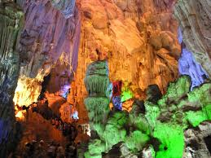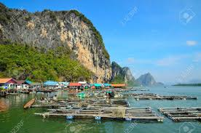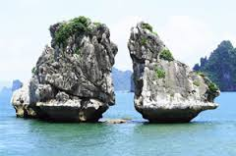
Paradise Grotto Fisherman Village Kissing Chicken Rock

After breakfast, transfer to Halong Boat station to take our private boat to visit Vietnam world Heritage Halong bay about about 4 hours, our boat will bring us to visit the Kissing Chicken Rock – Logo of Halong Bay, Fisherman Village, visit Paradise grotto - the place you can see all the scenery of Halong Bay, lunch will be served on boat with Halong fresh seafood, enjoy Viet Nam Coffee. In the Afternoon, transfer back to Hanoi. Dinner and overnight in Hanoi.

Meals: 1 Breakfast + 1 Lunch + 1 Dinner
Accommodation: Overnight in Hanoi
The distance: Halong Bay - Hanoi: 160km – 4 hours for transfer & break time on the way.

DAY 4: HANOI – LAO CAI – CAT CAT VILLAGE - SAPA (B/L/D)
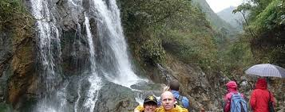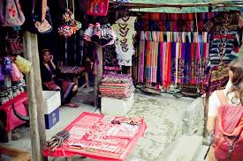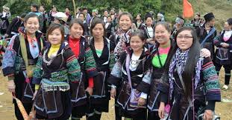
Cat Cat Village
Breakfast at hotel, transfer to Sapa ( It takes around 4.5 hours for transferring ). Arrival sapa at middle day. After lunch, following the road down to the valley by steps, walking to H’Mong Villagers ( Cat Cat Village ) working on the paddy fields and their animals, such as Chicken, Water Buffaloes and pot Bellied pigs. You can also see the old Hydro Electric Power Station which was built by the French time in early 20th century, and a beautiful waterfall that is the good place for resting. Back to Sapa town to visit Sapa Church, shopping at Sapa Minority People Market, dinner & overnight in Sapa.

Meals: 1 Breakfast + 1 Lunch + 1 Dinner
Accommodation: Overnight in Sapa
The distance: Hanoi - Sapa: 400km – 4 hours for transfer

DAY 5: SAPA - LAO CHAI – TA VAN VIILAGE – LAO CAI – HANOI (B/L/D)
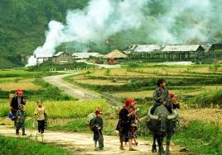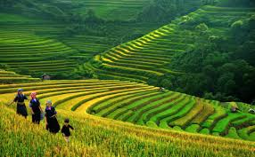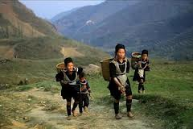
Lao Chai Ta Van
Breakfast at hotel, Embark on the lovely trek that will take a long buffalo path and trails and through several hill tribe villages Lao Chai, Ta Van, home to Black H’Mong and Dzay people. This is a absolutely spectacular walk through stunning scenery inhabitated by some of the valley floor, you can see really appreciate the wonderfull scenery surrounding you. the walls of the valley are covered with multi – layered rice terraced fields. After lunch, transfer back Hanoi.

Meals: 1 Breakfast + 1 Lunch + 1 Dinner
Accommodation: Overnight in Hanoi
The distance: Sapa - Hanoi: 400km – 4 hours for transfer

DAY 6: HANOI DEPARTURE (B)
Breakfast at hotel, free time for leisure then transfer to airport for flight home with sweet memories.

Meals: 1 Breakfast
The distance: Hanoi Capital - Noi Bai Airport : 35km – 45 minutes for transfer.
The ends of program!

SEQUENCE OF ITINERARY SUBJECT TO LOCAL ARRANGEMENT

PRICE INCLUDE:
- Accommodation – as hotel in the list or similar – based on Twin/Double/Triple sharing
- Tour guide: English or Chinese speaking guide during the tour.
- Daily ABF and meals as mentioned in the program
- Shows and sightseeing in schedule.
- Transportation by private air-conditioner.
01 bottle ( 500 ml )of drinking water for each pax per day.
- Meals (Vietnamese Food & Chinese Food) as the tour code ( B: Breakfast, L: Lunch, D: Dinner) 8-10 USD/meal/pax + one buffet at Sen Tay Ho Restaurant
- Boat trip in Halong.
PRICE EXCLUDE:
- International / Domestic flight ticket & airport tax (if have)
- Personal expenses: Tel, Fax, Mini Bar, Laundry,etc.
- Personal travel insurance
- Compulsory Tip for local guide and driver (USD/pax/day)

Group Size | Tips in USD
2 – 4pax | 6
5-7pax | 5
8 - up | 3

- Additional Meal will be surcharge 10usd/pax/meal.
- Surcharge with other languages guide
- Surcharge at hotel case by case
  - Chinese New Year (TBA)
  - Gala Dinner on X’Mas (24, 25 Dec ) & New Year 31 Dec

Hotel listed or Similar |  |  | All rates are next in USD/PAX  Valid Jan - Dec, 2020
 |  |  | Tour by private car / bus with private guide
HANOI | SAPA | HALONG | 2 | 3-4 | 5-6 | 7-9 | 10-12 | 13-15 | 15+1 | 20+1 | 25 +1 | 30+1 | Sgl up
Larosa 3*  Pomihoa 3*  First Eden 3*  Thang Long Espana 3*  Adamas 3*  Authentic 3* | Parorama 3*  Green Sapa 3*  Lacasa 3*  Sapa Vista 3* | Seastar 3*  Golden Bay Ha Long 3*  Sen Hotel 3* | 563 | 468 | 386 | 352 | 348 | 316 | 309 | 306 | 296 | 283 | 108
Thang Long Opera 4*  Chalcedony 4  Hotel Kuretakeso 4*  Lan Vien 4* | Sunny Moutain 4*  Relax 4* | Galaxy Ha Long 4*  Au Lac 4*  Mithrin 4*  Song Loc 4* | 608 | 513 | 430 | 396 | 391 | 360 | 348 | 345 | 333 | 318 | 153

NOTE
The timing of sightseeing points shall be fixing by local operator due to traffic and weather conditions, however all points must cover unless amendment or cancellation make by clients themselves (Non-refundable for any cancellation that made by clients)

Tour and price are subject to change without notice or incase of deduct number of pax in quoted group.

Small deviations in the tour program are sometimes necessary, depending on weather, road conditions, flight schedules and room availability.

Supplement charge for room rate in peak dates depends on the hotel category used. Compulsory gala dinner on X’mas, New Year’s Eve & Lunar New Year’s Eve to be advised upon booking. Prices for group of 15 persons up in 5 stars hotels sometime requires to re-quote bases on the hotel policy
01 FOC for tour leader based on twin sharing basis include breakfast (domestic air ticket is not applicable)

BUS

Group Size | Kind of Transportation
1-2 pax | 4 seater
3 pax | 7 seater
4-9pax | 16 seater
10-18 pax | 30 seater
19-21 pax | 35 seater
22 – 42 pax | 45 seater
OPTIONIAL INFO:

1/ Trishaw to visit 36 old quarters 10 USD/1 pax/ 1 trishaw
2/ Vietnamese traditional massage in Halong bay: 1h30 minutes including tips: 20 USD/ pax

- Commisstion 10% for tour leader

SHOPPING INFO:

1/ Vietnam local products
2/ Halong duty free jewelry center

- Commision 5% for Tour Leader

Tour request without shopping and no options will be surcharge 10USD/pax

CHILD POLICY

- Infant below 2 years old sharing same room with parents is free of charge.
- Child below 12 yrs old sharing same room with 1 ADL is charged for 90%.
- Child below 12 yrs old with extra bed and sharing same room with parents is charged for 65%.
- Child below 12 yrs old No extra bed & sharing same room with parents is charged for 55%

